Chapter 12, Solution 22.

Find the line currents I_{a}, I_{b}, and I_{c} in the three-phase network of Fig. 12.53 below. Take Z_{Δ} = 12 - j15Ω, Z_{Y} = 4 + j6 Ω, and Z_{l} = 2 Ω.
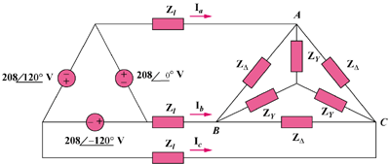

440∠0˚ V

440∠120˚ V

440∠–120˚ V

Figure 12.53
For Prob. 12.22.

Solution

Convert the -connected source to a Y-connected source.

Convert the -connected load to a Y-connected load.

Z

Z_{L}
+

V_{an}

I_{a}

32.88∠–28.4˚ A
32.88∠–148.4˚ A
32.88∠91.6˚ A

